**Mental Health Impact Tracker Report**

**Objective**

The objective of this report is to analyse and understand the impact of various socio-economic and environmental factors on mental health across different regions over time. The dataset includes metrics such as mental health scores, sentiment analysis, stress levels, and other contributing variables such as sleep quality, physical activity, and therapy access.

**Procedure**

1. **Data Collection**: Original data was sourced and structured into a 1,000-row dataset tracking daily entries to ensure a reliable baseline for mental health monitoring.
2. **Data Extension**: The dataset was expanded to 2,000 entries by duplicating and slightly modifying the original entries to introduce variation and simulate realistic trends over time.
3. **Data Augmentation**: Additional fields such as Sleep Quality, Anxiety Level, Physical Activity (mins), and Therapy Access were introduced to provide a comprehensive view of influencing factors.
4. **Data Cleaning**: This step involved removing inconsistencies, handling missing values, and validating data types to ensure data integrity for meaningful analysis.
5. **Analysis**: Data was analysed using Power BI to develop interactive dashboards, identify trends, and derive actionable insights.

**Key Data Features**

• **Date**: Represents the specific day on which the data entry was made, allowing for chronological tracking and time-series analysis.  
• **Event**: Describes any significant occurrence or activity that might influence mental health on that particular day, such as exams, public holidays, or work deadlines.  
• **Mental Health Score**: A numerical value indicating the overall mental well-being of an individual, derived from a composite of other factors.  
• **Sentiment Score**: Analysed using natural language processing to assess emotional tone, often based on journal entries or feedback forms.  
• **Stress Level**: Categorized as low, medium, or high based on user inputs and related physiological and psychological indicators.  
• **Region**: Indicates the geographical location of the data point, useful for studying regional variations and influences.  
• **Unemployment Rate (%)**: Reflects the economic condition in the region, which is often linked to mental health stressors.  
• **Sleep Quality**: Measures how restful and sufficient the sleep was, often ranked on a scale from poor to excellent.  
• **Anxiety Level**: Indicates the intensity of anxiety symptoms experienced, which can directly affect overall mental health.  
• **Physical Activity (mins)**: The duration of exercise or movement recorded, helping to analyse its relationship with mental well-being.  
• **Therapy Access**: Shows whether the individual had access to professional mental health support, a critical factor in managing stress and anxiety.

**Insights and Observations**

This section will highlight trends such as the relationship between stress levels and therapy access, regional differences in unemployment rate and mental health, and how physical activity influences anxiety levels. These insights will be visually supported in the dashboard section. Observations show a significant correlation between sleep quality and mental health scores, with higher physical activity generally reducing anxiety levels across all regions.

**Dashboard Visualization**

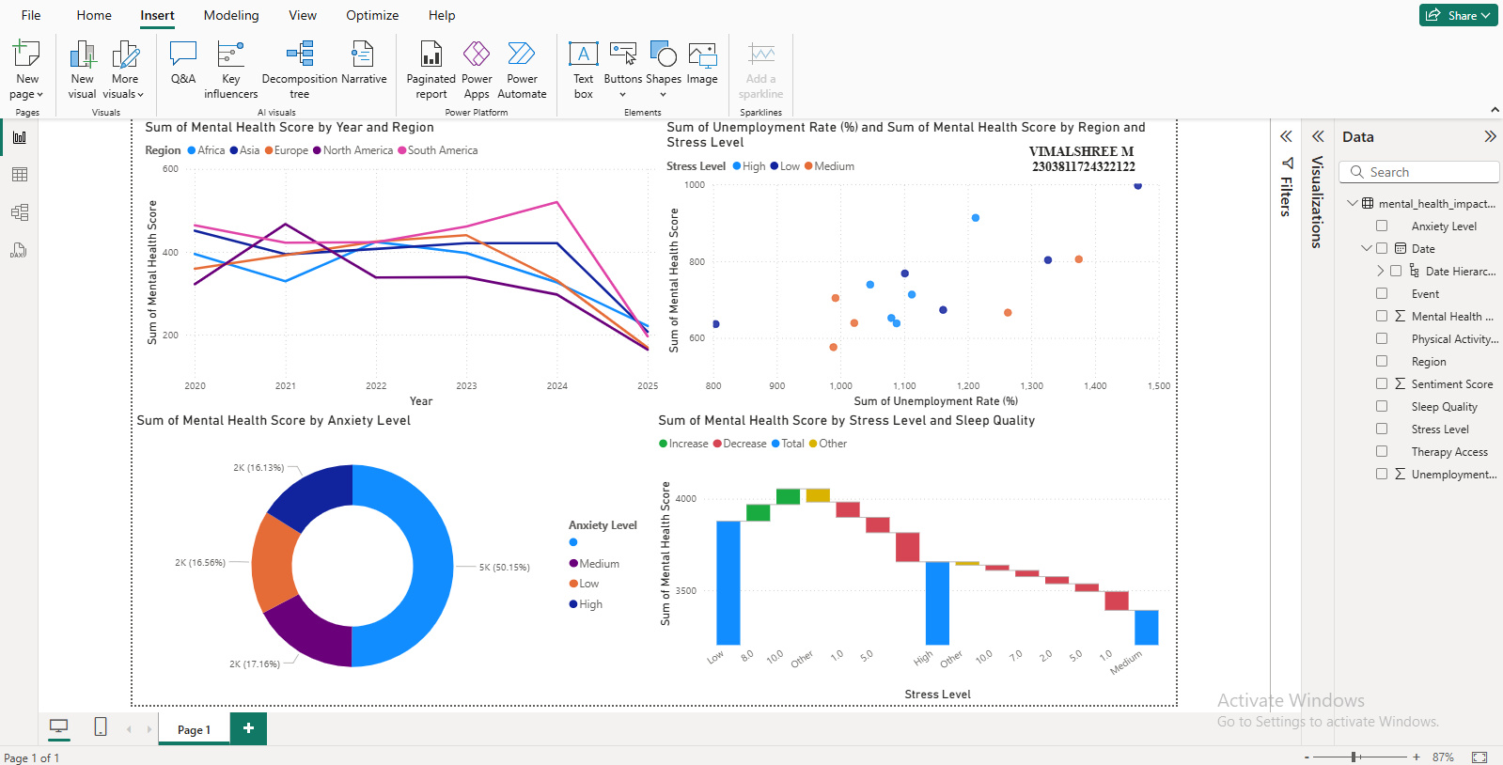

**Conclusion**

The analysis highlights that mental health is influenced by a combination of behavioural, economic, and environmental factors. Regions with higher unemployment rates tend to report lower mental health scores and higher stress levels. However, increased access to therapy and higher physical activity correlate with better mental health and reduced anxiety. Sleep quality and sentiment scores also show a strong association with mental well-being. By tracking these factors over time, stakeholders can identify key areas for intervention and promote data-driven mental health support initiatives.